“Engineering Aligned, Bioactive Polymers for Peripheral Nerve Repair”

Submitted to:
The 2019 RET Site at the University of Cincinnati
for
“Engineering Design Challenges and Research Experiences for Secondary and Community College Teachers”
Sponsored By
The National Science Foundation
Grant ID NO.: EEC-17110826
College of Engineering and Applied Sciences
University of Cincinnati, Cincinnati, Ohio
Reporting Period: June 10 - July 26, 2019

Prepared by:
Participant #1: Megan Brown, High School Science, Newport High School, Newport, KY
Participant #2: Akshayaa Venkatakrishnan, High School Science, Dater High School, Cincinnati, OH
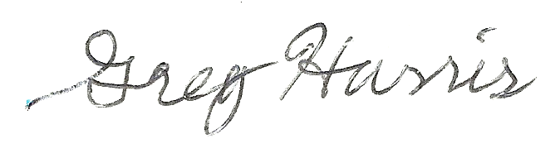
Approved By:
___________________________________
Dr. Greg Harris, PhD
Department of Chemical Engineering
College of Engineering and Applied Science
University of Cincinnati
Abstract

Tissue engineering provides a critical basis for regenerative medicine, a field of growing interest that combines biologically active scaffolds and materials to create or improve existing cellular systems. The extracellular matrix provides critical cellular signals for wound repair and cellular regeneration. The design of biocompatible scaffolds can include a variety of cells, and integration of a decellularized extracellular matrix into a biocompatible polymer scaffold can support conformation and alignment of cells; further, using biomaterials with piezoelectric properties can stimulate cell alignment and differentiation. The goal of this research is to determine the optimal conditions of a piezoelectric, bioactive scaffold that will create the most aligned tissue when cells are seeded on it.

Keywords: piezoelectricity, tissue engineering, regenerative medicine, biocompatible scaffold, extracellular matrix, electrical stimulation, cellular regeneration, nerve repair, wound repair

1. INTRODUCTION

The human body regenerates billions of cells every day, a process that we rely on in order to maintain the daily processes and structures that we rely on for survival. Damage to these systems can occur in a variety of ways and disrupt the mechanisms for cells to regenerate and recover in an effective manner.

This provides the basis for research in the field of tissue engineering, with specific subsets focusing on identifying new methods of enhancing cell growth and alignment to generate clinical solutions for cellular regeneration. This growing area of regenerative medicine provides an interdisciplinary approach combining the life sciences, biotechnology, and engineering to enhance the maintenance and restoration of tissue function and order. Polymer-derived scaffolds are synthetic materials that can be utilized in tissue to promote cellular regeneration. This tool can be used to promote wound healing, peripheral nerve repair, and other common sources of tissue or cell damage.

The human body utilizes several processes to maintain cellular function and send signals for cellular regeneration. One of these necessary biological components is the extracellular matrix, which is a network of proteins and macromolecules that provides a structure for cell adhesion, growth, and communication. Utilizing components of the extracellular matrix in a biocompatible scaffold could be beneficial in order to send vital signals for growth and alignment in damaged tissue.

Another critical property for cellular regeneration is piezoelectricity, which is a conversion of mechanical energy to electrical energy that occurs in the body to direct cellular growth and repair. When a change in conformation occurs, piezoelectric materials can induce a charge to stimulate a cellular response. Piezoelectric materials that are electrospun into biocompatible scaffolds could provide a three-dimensional matrix that can electrically stimulate a response in cells, removing the need for an outside source of electrical stimulation.

A biocompatible, piezoelectric scaffold that integrates biological material can be beneficial for cell growth, wound healing, and peripheral nerve repair. The piezoelectric properties of the scaffold will provide electrical stimulation upon deformation, and even without deformation can still be beneficial for cellular processes. The integration of a decellularized extracellular matrix creates a suitable environment for tissue and cell regeneration and benefits cell signaling. The combination of both biocompatible materials and piezoelectric polymers can create a scaffold that increases cell alignment and growth and promote wound healing and tissue repair.

2. LITERATURE REVIEW

Piezoelectricity is a property of certain biological tissues that causes an electric field to form when mechanical stress is applied to that tissue. This occurs when a biological tissue has a helical structure that results in a permanently polarized molecule. Examples of piezoelectric materials in the body are those with alpha-helical protein structures like keratin, collagen, and even DNA (Riberiro, Sencadas, Correia, & Lanceros-Méndez, 2015). Piezoelectricity is an essential property of many connective tissues as it starts a signal pathway that leads to the body regenerating these tissues when exposed to repeated mechanical stress (Rajabi, Jaffe, & Arinzeh, 2015).

The piezoelectric properties of body tissues allow for practical applications in tissue engineering. By harnessing these properties, scientists are able to grow different cells with directionality by using scaffolds-- helping with peripheral nerve repair, regeneration, and wound healing. The alignment of cells is critical for regenerated tissue to retain the same properties as native tissue. There are different scaffolds that researchers use in order to create aligned tissues. Scaffolds that have inherent piezoelectric properties show more enhanced cell motility and adhesion then control scaffolds (Ribeiro, Sencadas, Correia, & Lanceros-Méndez, 2015).

One of the most commonly used piezoelectric polymers is Polyvinylidene fluoride or polyvinylidene difluoride (PVDF), which not only has a large piezoelectric response but also can be electrospun to form fibers that readily mimics natural architecture of tissue (Ribeiro, Sencadas, Correia, Lanceros-Méndez, 2015). PVDF is mixed with a solute in order to be electrospun into a 3D conductive scaffold (Rajabi, Jaffe, & Arinzeh, 2015). One of the challenges of using PVDF is finding a solute for the polymer that is non-toxic to the body, which is a constraint for creating a scaffold that is biocompatible with the human body.

The extracellular matrix (ECM) is a web-like structure that is secreted by cells and provides structure and biological signals that allow cells to communicate (Harris et. al., 2017). In addition to using a piezoelectric scaffold, the best scenario to regenerate aligned tissue includes the formation of an ECM on the scaffold that is then decellularized and re-cultured with cells. While using only a scaffold will produce aligned cells, the cells typically do not extend as far --as seen in the neurite outgrowth study performed by Harris et. al. In order to produce the best clinical outcomes, the ECM should be decellularized in order to prevent an immune response in the patient. Not only does a decellularized ECM provide better clinical outcomes but it can create the ideal conditions needed for stem cells to differentiate and further promote neural regeneration, wound healing, or other tissue formation (Harris, Raitman, & Schwarzbauer, 2018).

3. GOALS AND OBJECTIVES

The goal of this research project is to assess the cellular alignment of 3T3 fibroblast cells and Schwann cells on an aligned polymer integrated with a decellularized extracellular matrix. To achieve this goal, three conditions were analyzed: (1) unaligned polymer without extracellular matrix (control), (2) aligned polymer without extracellular matrix, and (3) aligned polymer with the extracellular matrix.

The objectives for research were as follows: (1) electrospin the different polymer conditions with or without the extracellular matrix, (2) seed cells on each polymer condition, (3) incubate and grow cells, (4) mount cells and stain for cellular and extracellular components including actin, fibronectin, and DNA, and (5) image cells and quantify for cellular alignment.

4. RESEARCH STUDY DETAILS

For this research, participants learned the following techniques to learn how to conduct wet-lab research. Both participants reviewed literature and conducted background research in order to understand the piezoelectricity and procedures utilized to grow, decellularize, and analyze cell alignment. Prior to entering the laboratory setting, participants were trained in appropriate safety procedures to maintain a safe laboratory environment. In the first two weeks of the program, participants learned procedures that would help to identify, test, and analyze the research objectives, as outlined below. For the remaining three weeks, participants utilized these procedures and techniques to achieve the research objectives.

4.1 Seeding and Growing Cells to Develop an Extracellular Matrix

In order to incorporate biological material into a scaffold, cells were first grown to develop an extracellular matrix (ECM). Most cell types produce some level of ECM; for the purposes of this study, two types of cells were utilized. 3T3 fibroblast cells and Schwann cells were used. To transfer cells, in the wells where cell culture surfaces are stored, cell media must be removed. The wells are washed with 1x phosphate buffer saline (PBS). The PBS is removed and 2 ml of 2.5% trypsin in versene solution is added to detach cells from the surface. The cells are incubated at 37 degrees celsius for 3-5 minutes in the trypsin solution. Place the culture dish under the microscope to ensure that cells are detached. Add 4 ml of growth media to neutralize the trypsin. Transfer total solution from culture dish to 15 ml conical tube. Remove 10 microliters of total solution and add to hemocytometer for cell counting. Using a centrifuge, spin down the cells in the 15 ml conical tube at 1000 rpm for 5 minutes. Count the cells using a hemocytometer. Aspirate the media from the 15 ml conical paying careful attention not to dislodge the pellet. Add 2 ml of fresh media to the pellet. Use a pasteur pipette to resuspend the cells in the conical tube. Transfer the desired amount of solution to ensure the presence of 75000 cells/cm² into a culture dish. After 24 hours, remove media from the culture dish. Add growth media with 50 micrograms per microliter of ascorbic acid. After 48 hours additional hours, replace media once again. Continue replacing media in 48 hour intervals until the cells reach confluence across the culture dish for three or more days.

4.2 Decellularizing the Extracellular Matrix

The purpose of decellularizing the Extracellular Matrix is to avoid an immune response occurring in the patient by removing the DNA found in the cell’s nucleus. In order to achieve decellularization, wash and lysis buffers must be prepared and checked for the correct pH. Solutions must be room temperature before their pH is confirmed. After adjusting the pH of the solutions if needed, the cell media is removed from the wells where the cell culture surfaces are located. All washes and aspirations should be done on the side of the well to avoid disturbing the cell culture surface. The cell culture surface is washed with phosphate-buffered sulfate (PBS) twice.

After being washed with PBS, the first wash buffer is applied. In between each wash, PBS is used to rinse the cell culture surface. Lysis buffer is added to the wells to detach the cells from the ECM and the cell culture surfaces are incubated in the buffer. After the incubation time with the buffer, the cell culture surfaces are washed with wash buffer 2 twice. Finally, the cell culture surface is washed with distilled water four times and are stored in PBS for three days before use.

4.3 Electrospinning Techniques to Create Scaffold

The purpose of electrospinning is to create the PVDF scaffold that cells are grown on to encourage alignment. 20% of Polyvinylidene fluoride (PVDF-TrFE) was dissolved in a N-Dimethylformamide (DMF) and acetone (6:4) solution. This solution is added to a syringe; the electrospinning machine had a flow rate of 1 mL/hr. The tip of the needle was placed 10 cm away from the rotating collector and the needle tip had a speed of 2000 rpm. The applied voltage was 15 kV, and the collector was grounded with no charge. The polymers were then spun for either 1, 2, or 3 hours. Changes that were made for different conditions included adding decellularized ECM into the solution before electrospinning; for the unaligned fibers the collector was not rotating.

4.4 Seeding Cells on Biocompatible Scaffold

Transfer electrospun fibers onto glass coverslips. Add coverslips to wells. Use polytetrafluoroethylene rings to weigh down the polymer. Wash the polymer with 1x phosphate buffer saline (PBS) three times. Incubate at 37 degrees celsius for 15 minutes. Repeat the procedure from 4.1 to seed cells onto the polymer.

4.5 Immunohistochemistry Techniques and Mounting Cells for Microscopy

The purpose of staining is to make structures or proteins visible under different wavelengths of light to better identify cell structure and expression. By being able to easily identify cell structures under the microscope, the images taken on the microscope can be quantified for the alignment of the cells. In order to stain the different structures within the cells and extracellular matrix, the media must be removed from the wells where the cell culture surface is kept. The well is rinsed with 1x phosphate buffer saline (PBS) twice. After being rinsed with PBS, the well is filled with and incubated at 37 degrees celsius for 15 minutes in 3.7% formaldehyde to fix the cells. The formaldehyde is removed after the incubation and the wells are washed with PBS. The PBS is removed and 1 ml of Triton X is added into each well and allowed to incubate in the refrigerator for 5 minutes. Triton X ensures that cells are lysed so that the stain can penetrate the interior of the cell. Triton X is removed and the wells are filled with PBS. The coverslips are removed from inside the wells and placed in a petri dish covered with a paper towel. The paper towel is dampened with distilled water in order to retain humidity. Each coverslip is rinsed three times in PBS and one time in distilled water. After being cleansed and dried with a Kimwipe, each coverslip is added onto a petri dish for staining. Different staining solutions are prepared depending on what structure you are wanting to view during microscopy. The staining solution is added dropwise on top of the coverslip. After applying the staining solution, the coverslips are incubated for 30 minutes. After the appropriate stain is applied and the coverslips have incubated, mounting solution is used to secure the coverslip to the microscope slide. The coverslips are applied “polymer down” in order for the polymer to be viewable with a light microscope. The microscope slides are left to set overnight and are sealed with clear varnish the following day.

4.6 Microscopy Techniques and Alignment Analysis

Participants learned how to seed cells onto polymers in a sterile environment, how to utilize immunohistochemistry to stain for different proteins, and how to decellularize cells to remove DNA and keep the extracellular matrix. Once participants learned laboratory procedures, they learned how to use a sophisticated light microscope to image slides of cells grown on a substrate and their extracellular matrices. Once participants acquired images of the cells on the polymers, participants were taught to use ImageJ--an analysis tool--in order to quantify the alignment of cells.

5. RESEARCH RESULTS AND DISCUSSION

Participants analyzed three conditions: (1) unaligned polymer without extracellular matrix (control), (2) aligned polymer without extracellular matrix, and (3) aligned polymer with the extracellular matrix. Participants identified the following findings from the research conducted.

5.1 Microscopy Images

Participants imaged cells after staining to visualize alignment of cells. The following images shows an unaligned and an aligned image; the first image is cells grown without a scaffold. The second image are cells grown on a 3 hr. aligned PVDF polymer.

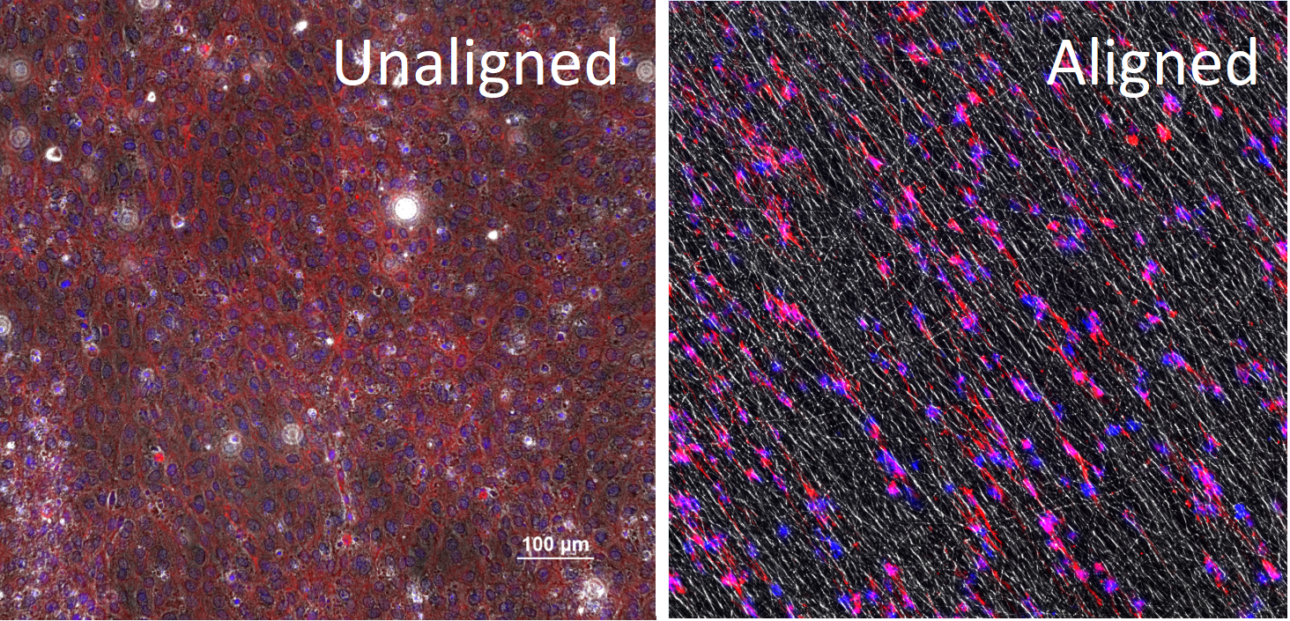
Fig. 1: Unaligned cells grown without a scaffold and aligned cells grown with a scaffold.

5.1 Degree of Alignment

In order to analyze for alignment, participants utilized ImageJ software to conduct an analysis based on Fast Fourier transforms using spatial pixel intensity from the microscopy images. Participants compared each of the following conditions for degrees of alignment; this informed the alignment of the cells based on quantification using ImageJ software. This data is further broken down in the following sections, but presented in its entirety below to compare alignment.

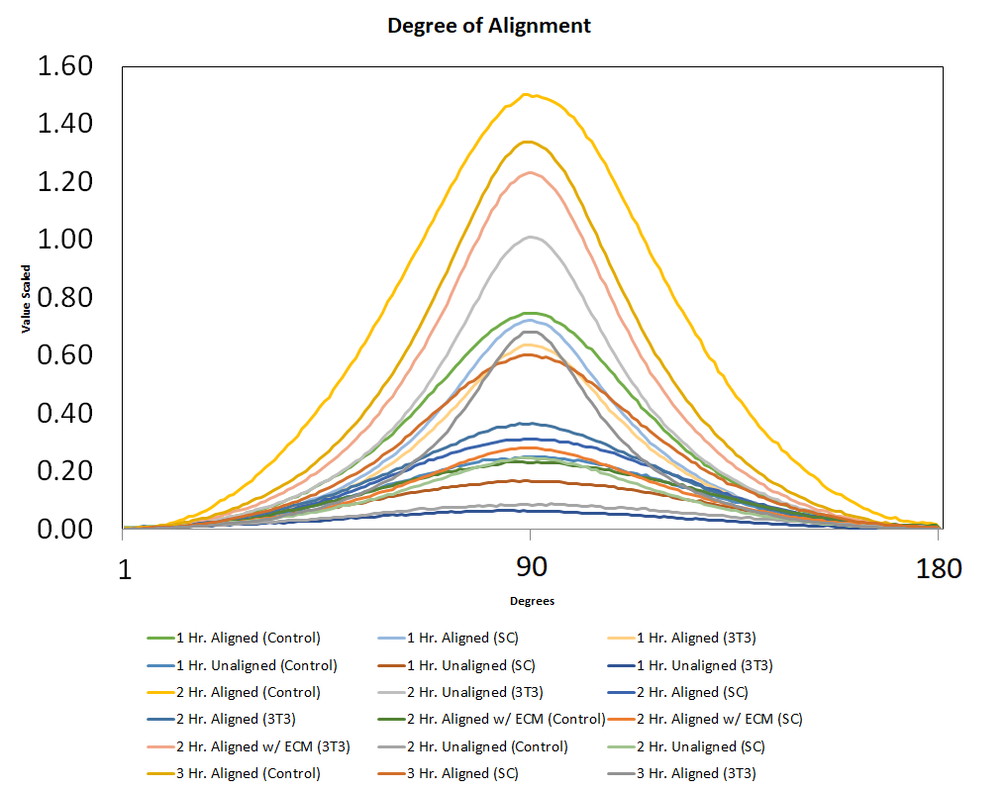
Fig. 2: Degrees of Alignment for All Conditions

Based on this data, the most aligned condition was the aligned polymer that was spun for 2 hours with no cells. The aligned polymer that was spun for 3 hours was the second most aligned.

5.2 Full Width-Half Maximum Comparison

Participants then analyzed the full width-half maximum of the data; this analysis is beneficial to determine how close the range of each set of data is to 90 degrees. The smaller the full width-half maximum is, the closer the range of data is to 90 degrees which signals alignment.

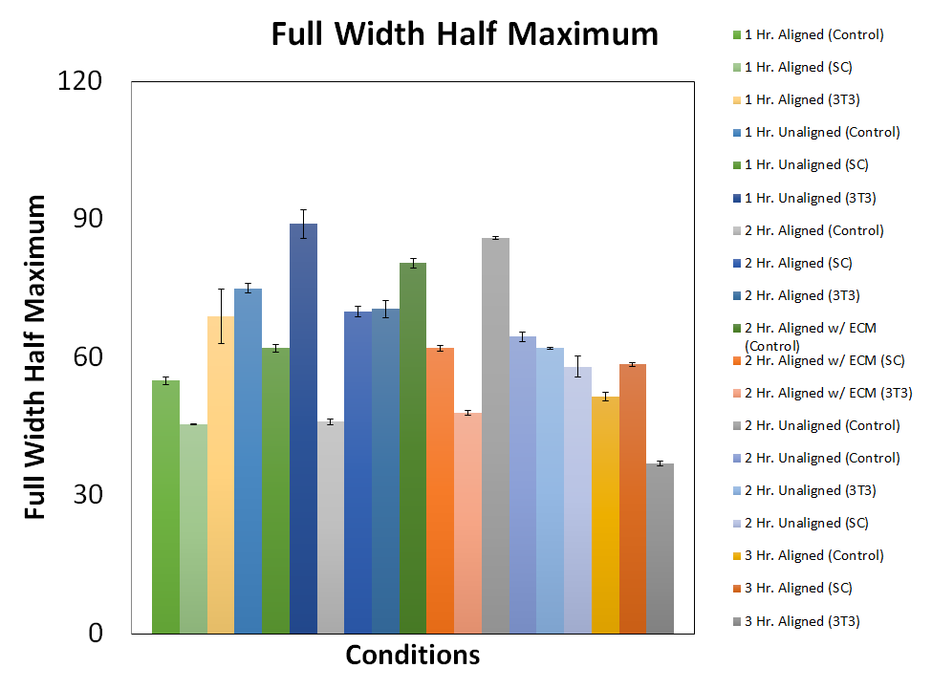
Fig. 3: Full Width Half Maximum Analysis
Based on the full width-half maximum analysis, the two conditions with the smallest full width-half maximum was the 2 hour aligned control polymer and the 3 hour aligned polymer seeded with 3T3 cells.

5.3 ANOVA Test

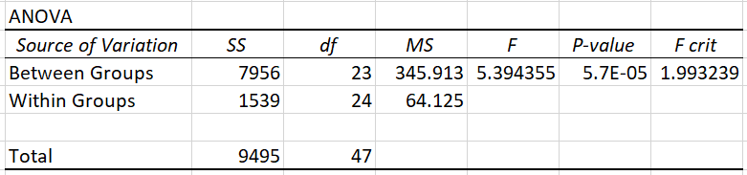
Fig. 3: Single ANOVA Analysis

Participants conducted a single factor ANOVA analysis on the presented conditions. The p-value from this analysis is 5.7E-05 suggesting that there is a statistical difference in the set of data. This data provides a starting point for analysis to demonstrate that data from test conditions were not equal, suggesting variance between the test groups.The F criteria of 1.99 also shows variance between conditions and low variance within groups.

5.4 Unaligned Polymer and Aligned Polymer Comparison

The following data shows the comparison for full width-half maximum analysis for aligned and unaligned polymers. Figure 3 shows the comparison for aligned and unaligned polymers; upon conducting a t-test comparing all data for aligned conditions to all data for unaligned conditions, a p-value of 0.005115 shows a statistical difference in the set of data.

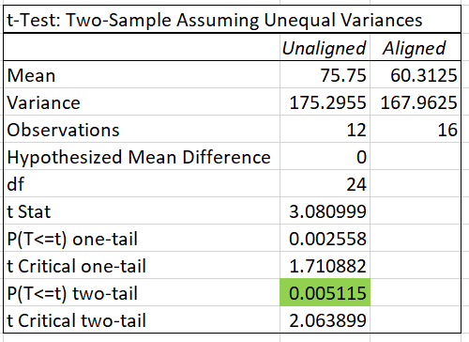
Fig. 4: T-test for Aligned versus Unaligned Conditions

Aligned polymers that were spun for 2 hours with or without decellularized ECM is analyzed below; Figure 4 shows the degree of alignment for the averages of the data, and Figure 5 shows the full width-half maximum alignment for both sets of data.

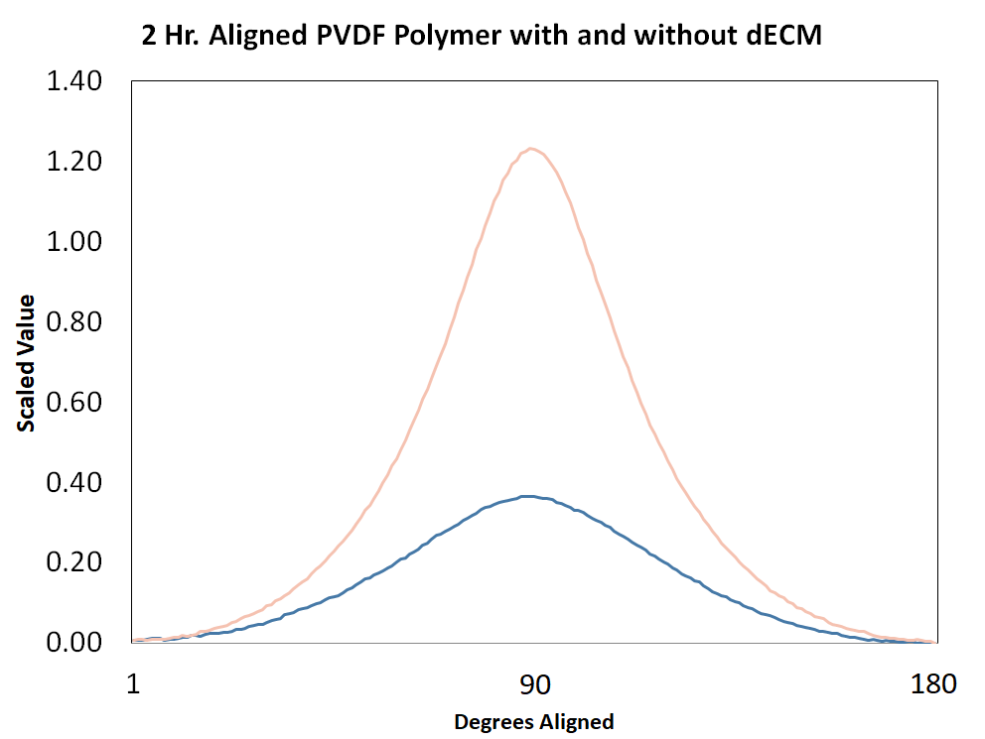
Fig. 5: Alignment for 2 Hr. PVDF Polymer with and without decellularized ECM for 3T3 Cells

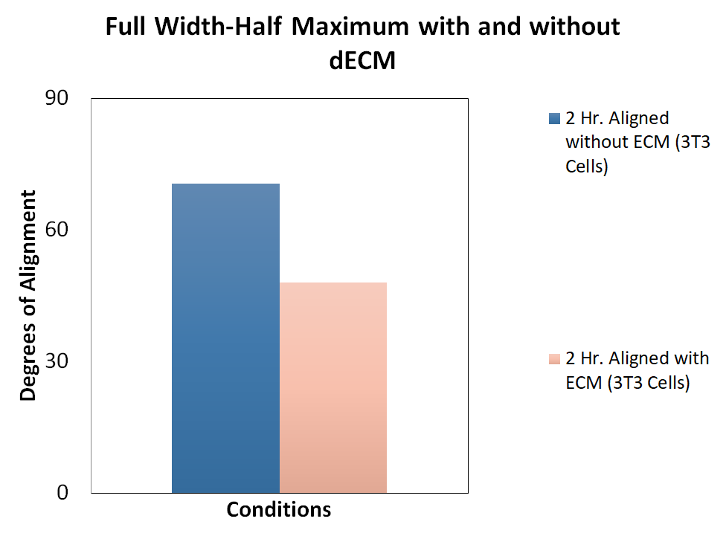
Fig. 6: Full Width-Half Maximum for alignment with and without decellularized ECM for 3T3 Cells.

6. CONCLUSION

The goal of analyzing alignment of cells grown on a piezoelectric polymer electrospun with decellularized ECM was achieved in terms of characterizing alignment of cell growth in three different conditions. Based on the data, a statistical difference exists for alignment of the aligned and unaligned polymers and there was a difference in alignment for 3T3 cells grown on 2 hour-spun polymers with and without decellularized ECM, showing higher alignment for polymers with dECM. This could result from an increase in more protein binding sites in the ECM that benefits proliferation of cells along the length of polymers or provides molecular signalling for alignment. A challenge for this initial data collection was the limited amount of data collected for each condition, with only two trials collected for condition. For further research and validation, we recommend collecting further data for these conditions for more accurate analysis.

7. RECOMMENDATIONS

To build on the data the participants collected, the researchers can continue to collect data on the alignment of the conditions addressed in the results section. By continuing to collect data about these conditions, the researchers will obtain a better sample size and be able to more accurately determine the statistical significance of the data. Researchers will continue to electrospin the extracellular matrix into the PVDF polymer. No statistical difference exists between the alignment of 3T3 cells and Schwann cells. With more trials, the researchers will be able to better characterize the new combined surface and determine its effect on alignment.

With more trials, the researchers will be able to optimize the best possible polymer combination in order to create the best clinical outcomes. In the future, the researchers will use this polymer scaffolds in vivo to test their regenerative properties.

8. CLASSROOM IMPLEMENTATION PLAN

Megan’s unit that will be implemented focuses on mitosis, the cell cycle, and conditions that can interrupt these processes. Initially, students will read an excerpt of The Immortal Life of Henrietta Lacks to introduce students to the consequence of dysfunction in the cell cycle. The hook will lead students into asking guiding questions about cell replication. In Lesson 1, students will focus on learning the steps of mitosis and the cell cycle. Students will explore the steps of mitosis through labs and the engineering design process in order to think about mitosis as an engineering problem rather than rotely memorizing the steps of mitosis. In Lesson 2, students will focus on dysfunction of the cell cycle and conditions that can cause cell cycle dysfunction. Students will explore the essential question: “What happens to my body in space?” and will explore the impacts of radiation damage and microgravity. These two challenges of space travel will lead students into learning about Megan’s summer research and also into the final activity. The final activity is the challenge. Students will create a product that will protect yeast cells from UV light and heat for 24 hours to simulate a product that would protect astronauts from radiation. Students will choose from various materials to create their product and will produce two iterations within given constraints and criteria. See Megan's Wiki for the unit and activity templates.

Akshayaa’s classroom implementation plan covers feedback cycles and pain. Pain is a nearly universal experience that sends a signal that something might not be quite right with the body. In this unit, students will assess the factors and conditions that might initiate pain, and use their knowledge of homeostasis and feedback loops to design and implement a product to help people in pain. For the hook, students will investigate the connections between lab safety rules and potential outcomes. Several examples of pain will be given: a Lil Uzi Vert song lyric about heartbreak, a person stepping barefoot on blacktop pavement on a sunny day, or feeling sore muscles when you wake up after running without stretching. Students will discuss and debate whether these three sources are the same type of pain or not and why. In the first lesson, students will identify different situations in which the body will react to outside stimuli and adjust behavior and regulation to maintain homeostasis; students will then design an experiment to identify the role of regulation in planarian. Students will choose one type of regulation in groups to regulate and identify the change in behavior based on different conditions. For the second lesson and challenge, students will brainstorm, research and design in groups to understand the role that feedback loops play in pain, and will learn about the interdisciplinary fields that play a role in our understanding of pain. Students will take on the role of biomedical engineers to develop an understanding of the role of medication in the mediation of pain, and develop sustainable non-pharmaceutical solutions that address and relieve pain for a client in their lives. See Akshayaa’s Wiki for unit and activity plans and resources.

9. ACKNOWLEDGEMENTS

The participants of this program and research study would like to acknowledge and thank the National Science Foundation for funding the Research Experience for Teachers for the resources and financial support provided through this program. They would also like to acknowledge and thank the guidance, expertise and support of faculty mentors Dr. Greg Harris and Dr. Leyla Esfandiari, Graduate Research Assistants Jacob Orkwis and Emmy Cady, and undergraduate students Ann Wolf and Minhaj Shahed. Gratitude would also like to be extended to the RET Principal Investigator Dr. Margaret Kupferle, RET Resource Person and Grant Coordinator Mrs. Lora Buchanan, and RET Resource Teacher Mrs. Pamela Truesdell.

The RET program is funded by the National Science Foundation, Grant ID# EEC-17110826: “Engineering Design Challenges and Research Experiences for Secondary and Community College Teachers.” Any opinions, findings, and conclusions or recommendations expressed in this material are those of the authors and do not necessarily reflect the views of the National Science Foundation.

10. BIBLIOGRAPHY

Anderson, M., Shelke, N. B., Manoukian, O. S., Yu, X., McCullough, L. D., & Kumbar, S. G. (2015). Peripheral nerve regeneration strategies: electrically stimulating polymer based nerve growth conduits. Critical Reviews™ in Biomedical Engineering, 43(2-3).

Belin, S., Zuloaga, K. L., & Poitelon, Y. (2017). Influence of mechanical stimuli on Schwann cell biology. Frontiers in cellular neuroscience, 11, 347.

Harris, G. M., Raitman, I., & Schwarzbauer, J. E. (2018). Cell-derived decellularized extracellular matrices. In Methods in cell biology (Vol. 143, pp. 97-114). Academic Press.

Harris, G. M., Madigan, N. N., Lancaster, K. Z., Enquist, L. W., Windebank, A. J., Schwartz, J., & Schwarzbauer, J. E. (2017). Nerve guidance by a decellularized fibroblast extracellular matrix. Matrix Biology, 60, 176-189.

Rajabi, A. H., Jaffe, M., & Arinzeh, T. L. (2015). Piezoelectric materials for tissue regeneration: A review. Acta biomaterialia, 24, 12-23.

Ribeiro, C., Sencadas, V., Correia, D. M., & Lanceros-Méndez, S. (2015). Piezoelectric polymers as biomaterials for tissue engineering applications. Colloids and Surfaces B: Biointerfaces, 136, 46-55.

11. APPENDIX

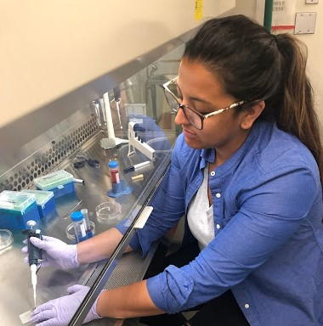
Fig. 7: Participant is pipetting cell media into a hemocytometer to count cells. Counting the cells ensure that there are enough cells to have a successful culture.

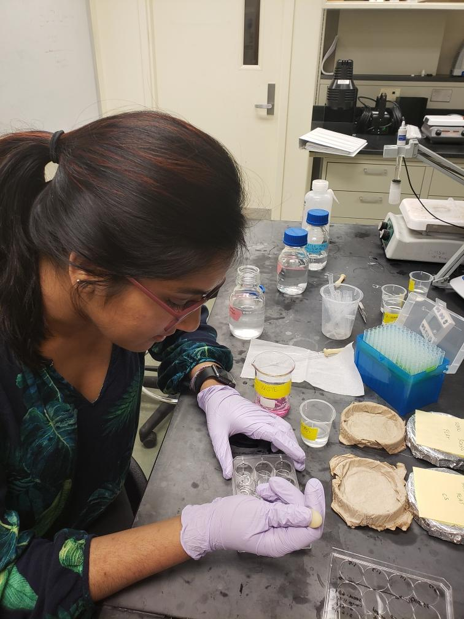
Fig. 8: Participant performing a cell mounting protocol. Participant is staining the cells for actin, fibronectin, and DNA in order to determine how aligned the cells are on the PVDF polymer.

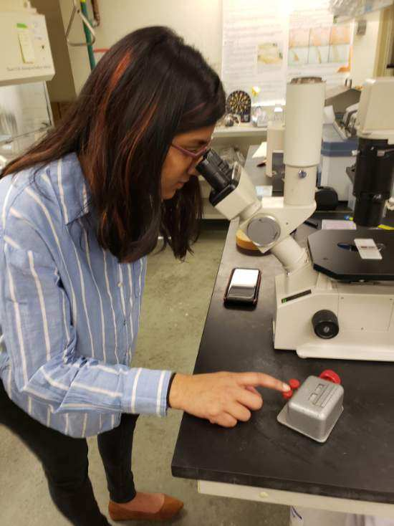
Fig. 9: Participant counting cells in a hemocytometer under a microscope. This step ensures even cell dispersion for seeding.

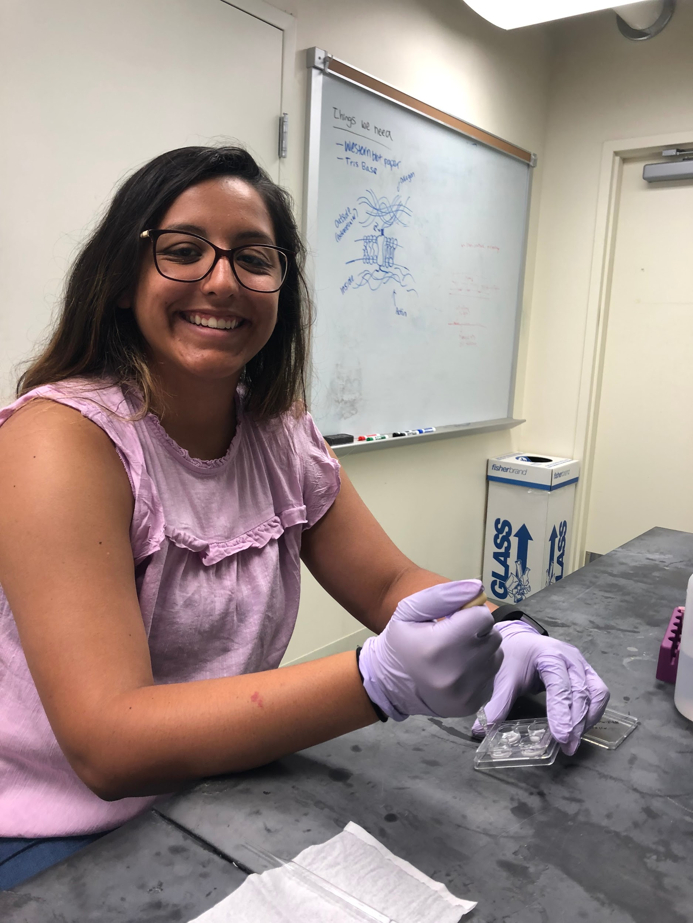
Fig. 10: Participants removes media from cells to prepare cells for staining and mounting.

